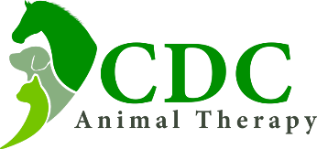
Veterinary Practice
Name
Address
Email Address
Telephone Number
Client’s Details
Name
Address
Email Address
Telephone Number
Pet’s Information
Name
Breed
Age
Reason for Treatment
Medication

This is to confirm that the Veterinary Practice has no objections for the above pet to be treated at CDC Animal Therapy. Please, contact Katarina directly if you wish to receive after-treatment update.
Please provide veterinary history for the above pet and attach it to this form (either by email or as printed copy).
Date: ………………………………………………………………………………………….………....
Veterinarian Full Name (printed): ……………………………………………………….…
Stamp and Signature of Veterinarian: ……………………………………………………

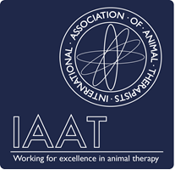
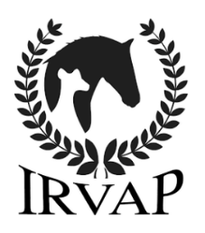
Katarina Kmecova is fully qualified Canine Sports Massage Therapist (qualification obtained at The College of Animal Therapy, UK), currently studying Diploma in Animal Physiotherapy, member of the IAAT (International Association of Animal Therapists) and IRVAP (Institute of Registered Veterinary and Animal Physiotherapists). CDC Animal Therapy offers wide range of musculoskeletal treatments. Please contact Katarina using the below contact details for any additional information required.

